Students Handout

MVC(Model View Controller)Exercise

**Overview:**

In this exercise, you will create a simple Job Portal with three controllers:JobProviderController, and Public Controller. The application allows job Provider to register, log in, view and update their profiles,

Post jobs ,List all posted jobs, and view JobProvider Dashboard Using EF.

**Technologies:**

ASP.NET Core MVC

C#

Repository Pattern

Dependency Injection

Exercise Steps:

1.Create a public Controller with actions

Registration

Login

2.Create a Job Provider Controller with actions

JobProvider Profile

Post Job

List All Jobs

Dash Boorad

**Repository Pattern:**

Implement a generic repository pattern for handling data access.

Create repositories for User(login,Registration,GetbyId), and JobProvider(post job,Get Jobs)

Register services in IOC Container

**Screens**

**Registration**

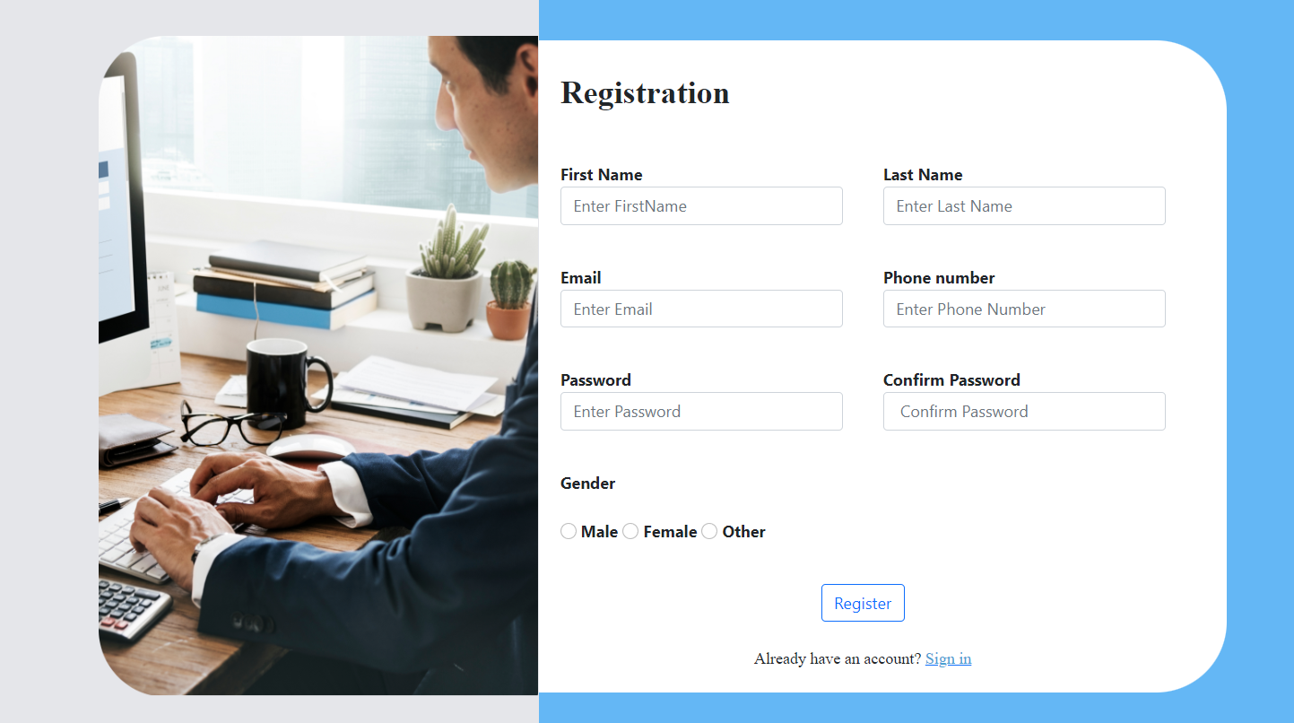

**Login**

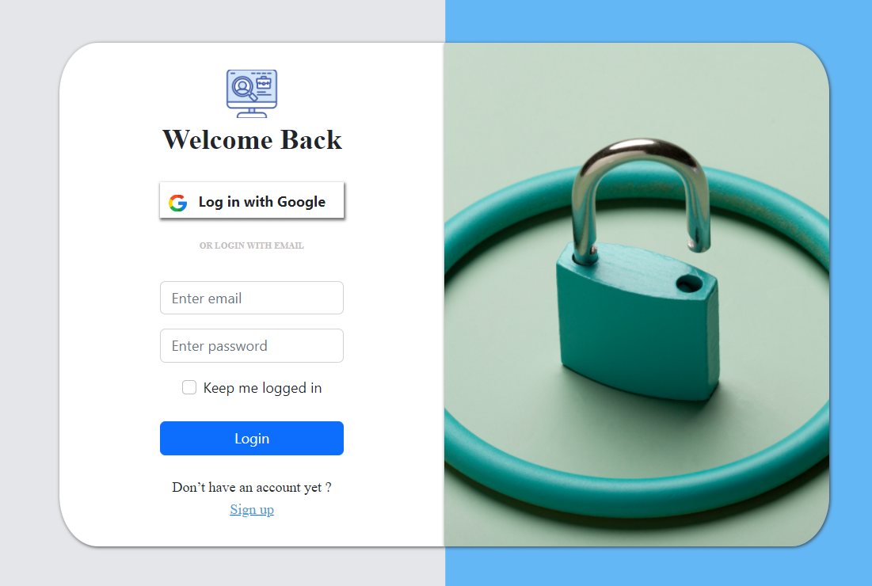

**JobProviderProfile**

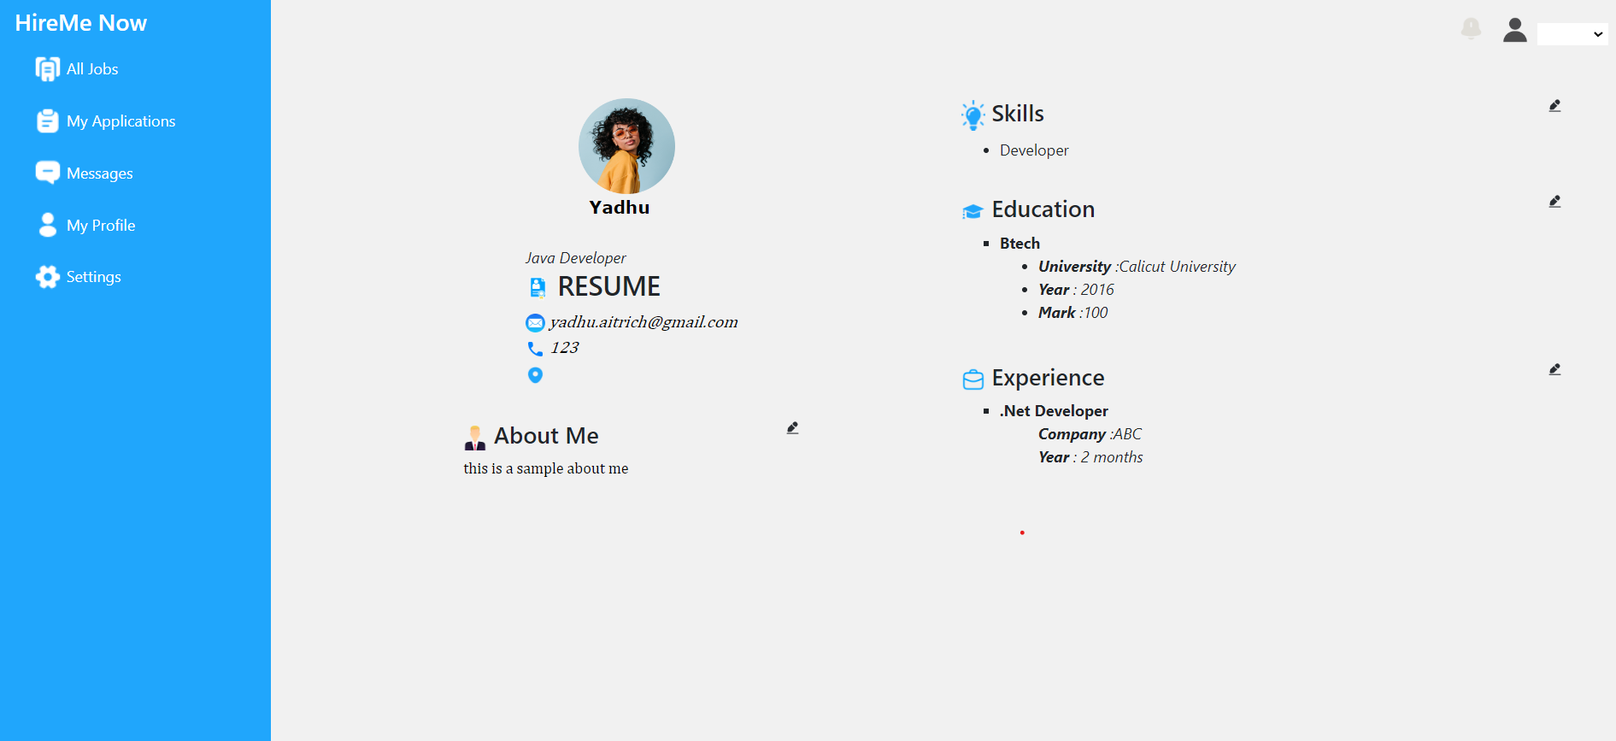

**Post Job**

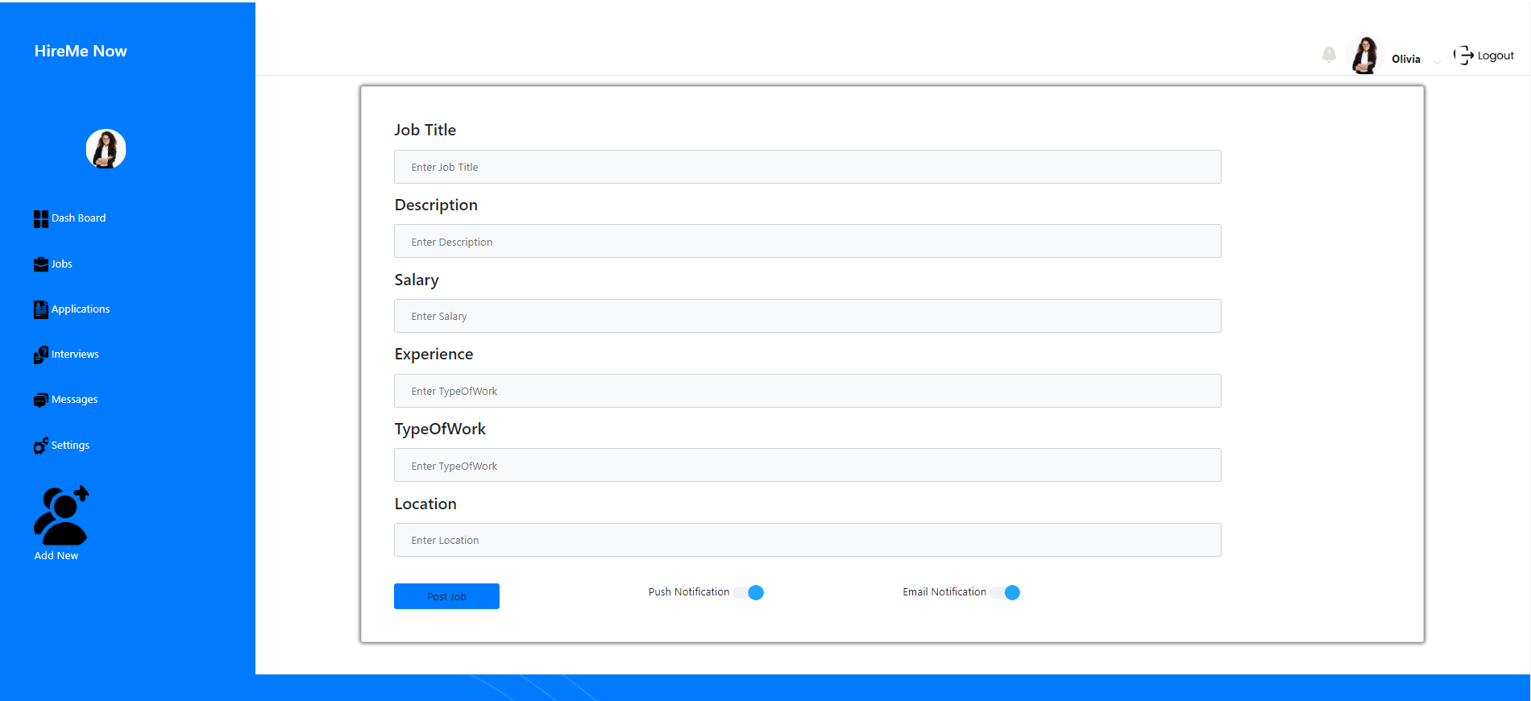

**List All Jobs**

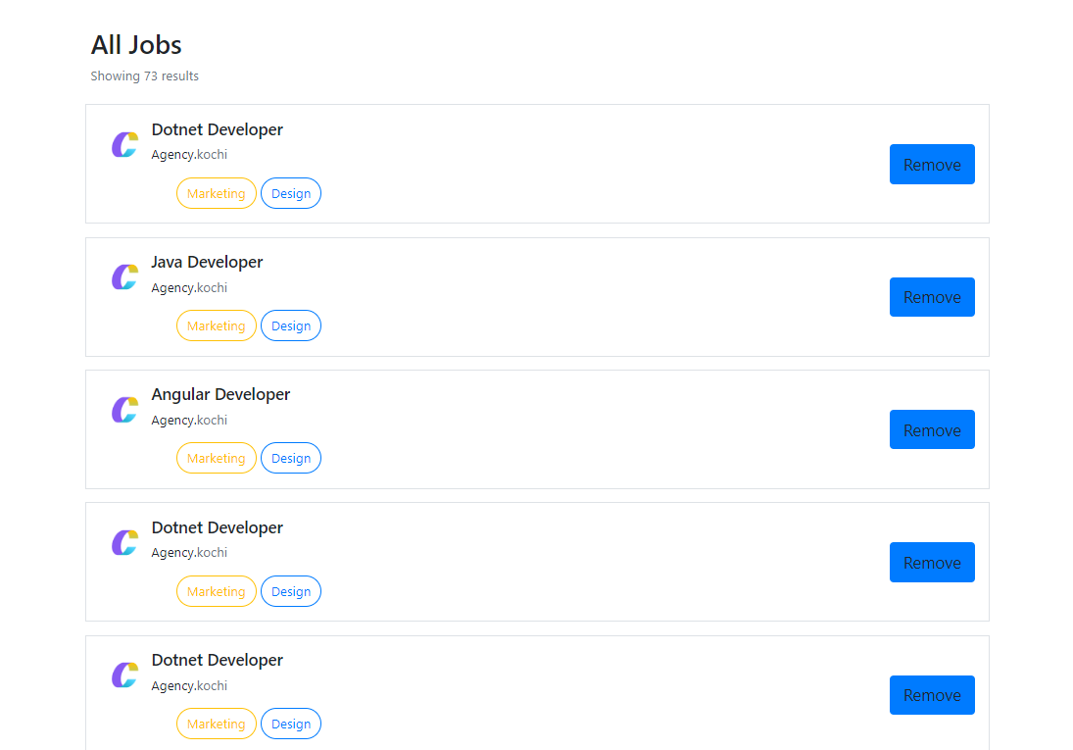

**Dashboard**

